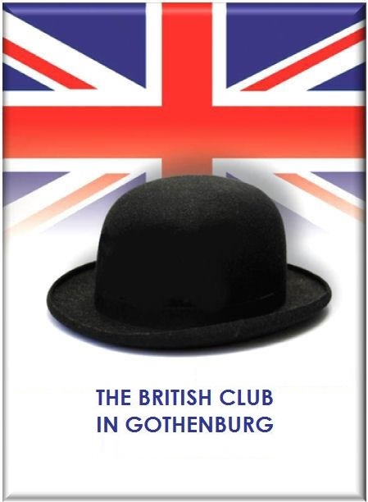
The British Club in Gothenburg is a social club offering ‘the best of the British Isles’ in the West of Sweden. Membership is open to people with some connection to Britain, regardless of their nationality.

The club is run on a voluntary basis and enjoys, as the mainstay of its activities, a series of social gatherings for members to meet in a friendly English language environment. Club members get discounts on some cultural events in English during the year.

You can find our coming social gatherings, as well as tips about local events in English and other news on our website: https://britishclub.se/

Application for Membership

(Membership includes family members in the same household.)

Name of applicant

Surname: First name:

Please tell us something about your connection to the British Isles:

Applicant’s address:

Telephone number(s):

Email address:

Date:

Please return the completed form to:
membership@britishclub.se

For more information about the British Club, please contact the Membership Secretary: membership@britishclub.se
or the Chairperson: john.chaplin@britishclub.se

